**ISAD251**

**Database Application**

**Development**

**20 CREDIT MODULE / 50% COURSEWORK SUBMISSION**

**/ 50% EXAM**

**MODULE LEADER: SHIRLEY ATKINSON**

**MODULE LECTURER: WILLIAM PANG**

**STUDENT:**

Name: WONG, WING HO

Student ID: 20042520

1. **Storyboard of Application**

* For Public & Customer

This is the landing page for all people.  
  
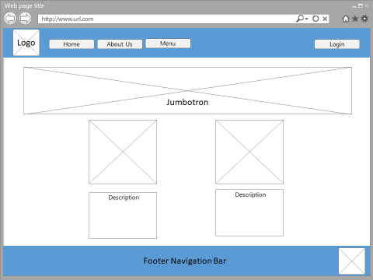

Public will see a “Sign-in” bottom at the “Menu”.  
  
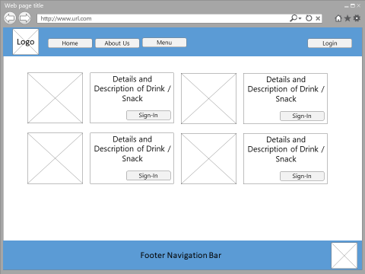

Public are required to sign-up for ordering items.

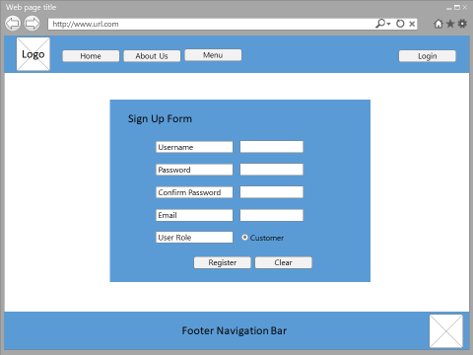

Customer are required to sign-in for ordering items.

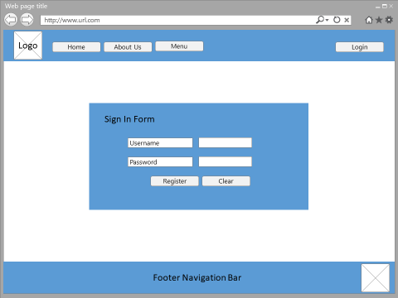

After sign-in, a button “Add to Cart” will be displayed in the Menu Page. Customer can check other added item in the “Shopping Cart” at the top of navigation bar. If customer is ready to checkout, just click “checkout”

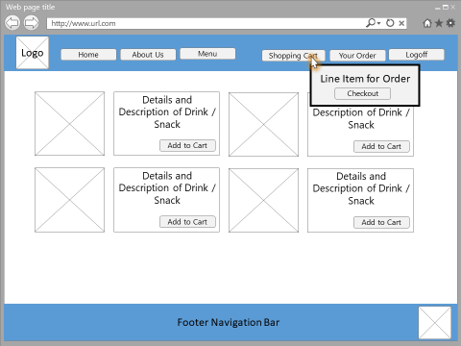

An order form will be displayed. Corresponding line item will be listed.

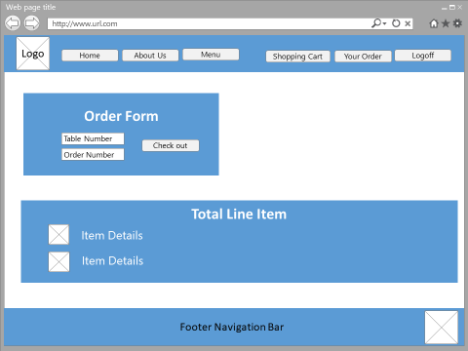

This is the page for customer who want to check their orders.

More details of ordered items can be checked by selecting “OrderDetails” button

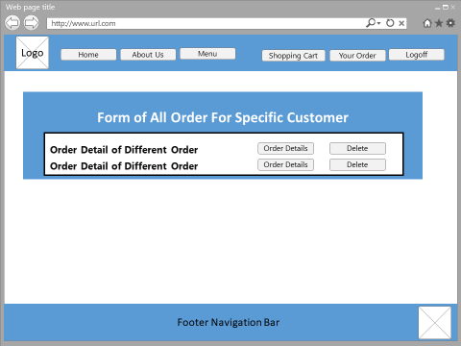

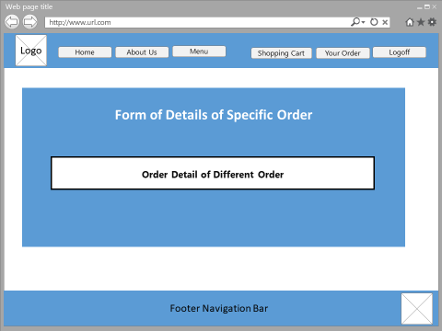

* For Administrator

Administrator is required to log-in.



Two different tab (Product Management & Order Management) will be shown after administrator is logged-in.

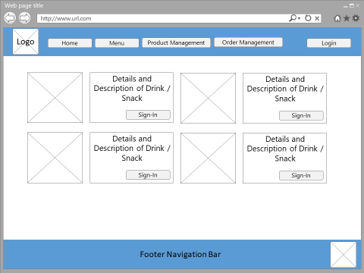

This is the page of product list. Administrator can view details of items, create new items, or edit specific item.

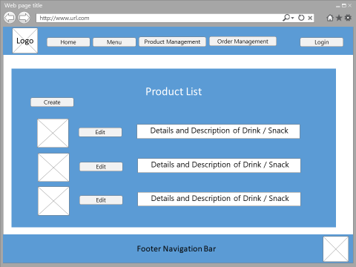

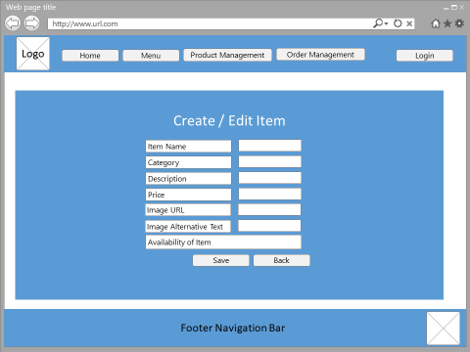

This is the page for administrator who want to check all customers’ orders.

More details of ordered items can be checked by selecting “OrderDetails” button

It also provide a searching function for administrator to search specific user’s order by name.

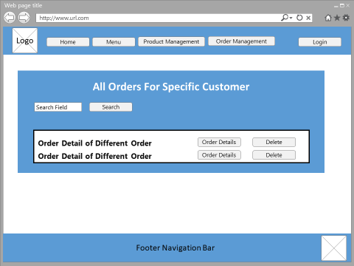

1. **ER-Diagram**

* For Database (BarContext)

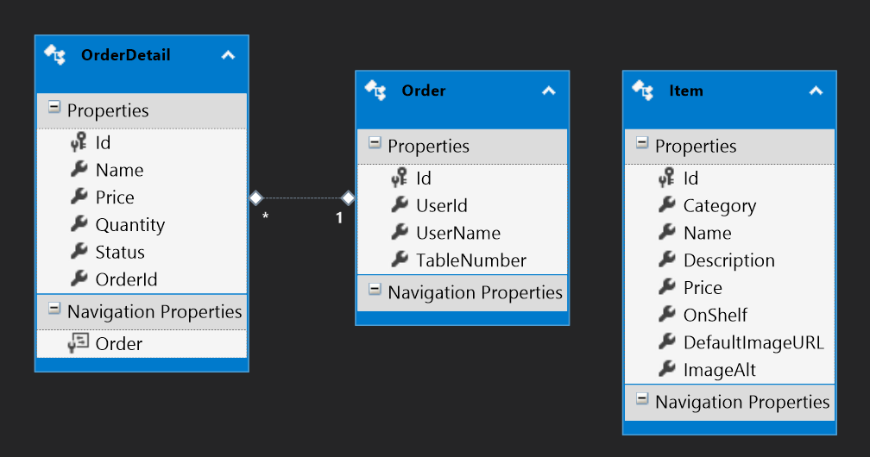

* For Database (Default Connection)

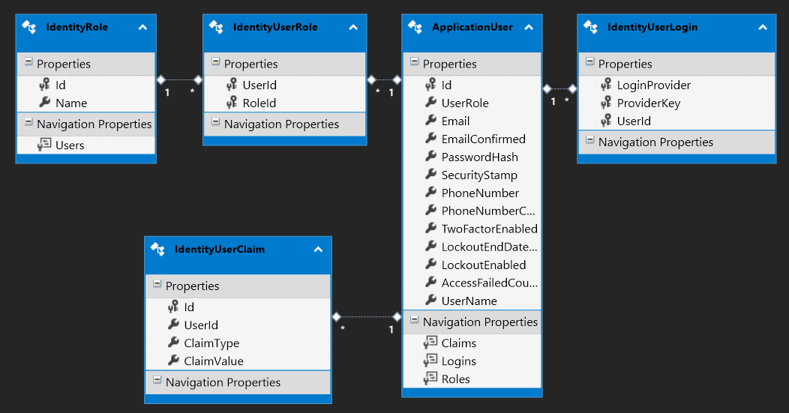

1. **Any Setting and Images**

* For Website Design

|  |  |
| --- | --- |
| C:\Users\whwong\AppData\Local\Microsoft\Windows\INetCache\Content.Word\About_us_jumbotron.jpg | C:\Users\whwong\AppData\Local\Microsoft\Windows\INetCache\Content.Word\bg.png |
| C:\Users\whwong\AppData\Local\Microsoft\Windows\INetCache\Content.Word\jumbotron.jpg | C:\Users\whwong\AppData\Local\Microsoft\Windows\INetCache\Content.Word\recommended_drinks.jpg |
|  |  |
|  |  |

* For Item Product

|  |
| --- |
| C:\Users\whwong\Desktop\Project\V4\FormosBar\FormosBar\Content\img\ItemPhotos\Ardbeg_10.jpg C:\Users\whwong\Desktop\Project\V4\FormosBar\FormosBar\Content\img\ItemPhotos\Glenlivet_18Y.jpg C:\Users\whwong\Desktop\Project\V4\FormosBar\FormosBar\Content\img\ItemPhotos\Lagavulin_16Y.jpg |
| C:\Users\whwong\Desktop\Project\V4\FormosBar\FormosBar\Content\img\ItemPhotos\Mortadella_Pizza.jpg C:\Users\whwong\Desktop\Project\V4\FormosBar\FormosBar\Content\img\ItemPhotos\Haggis.jpg C:\Users\whwong\Desktop\Project\V4\FormosBar\FormosBar\Content\img\ItemPhotos\Buffalo_Wings.jpg |

1. **Evidence of Browser Compatibility**

* Google Chrome  
    
  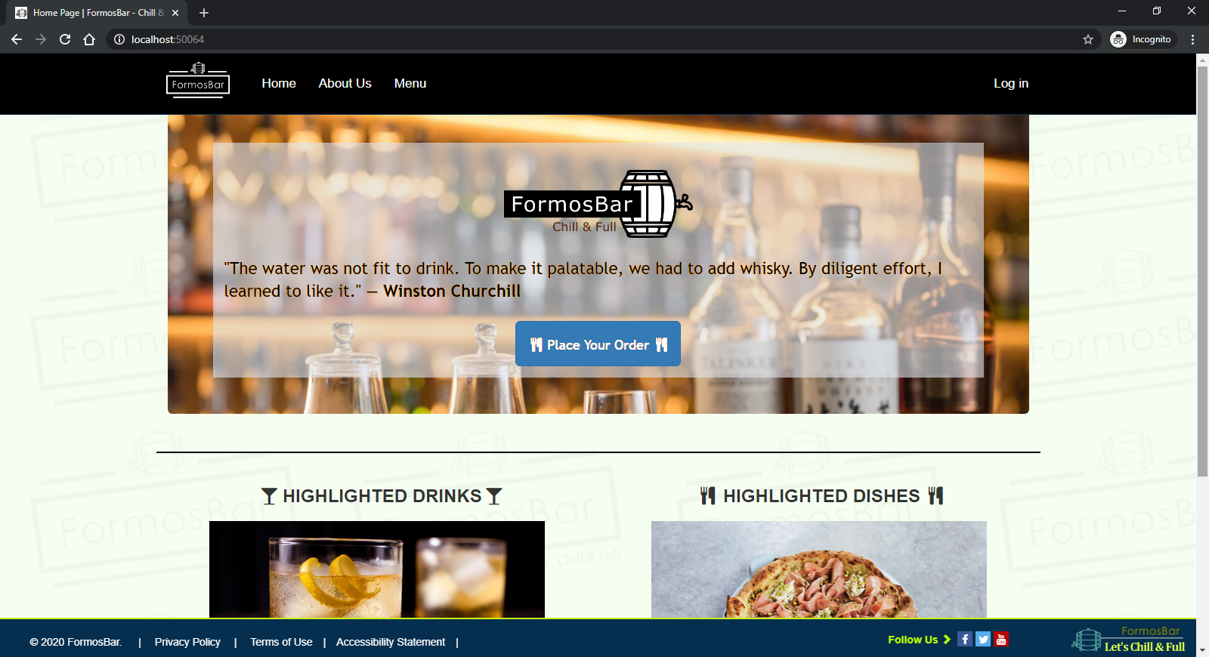  
    
  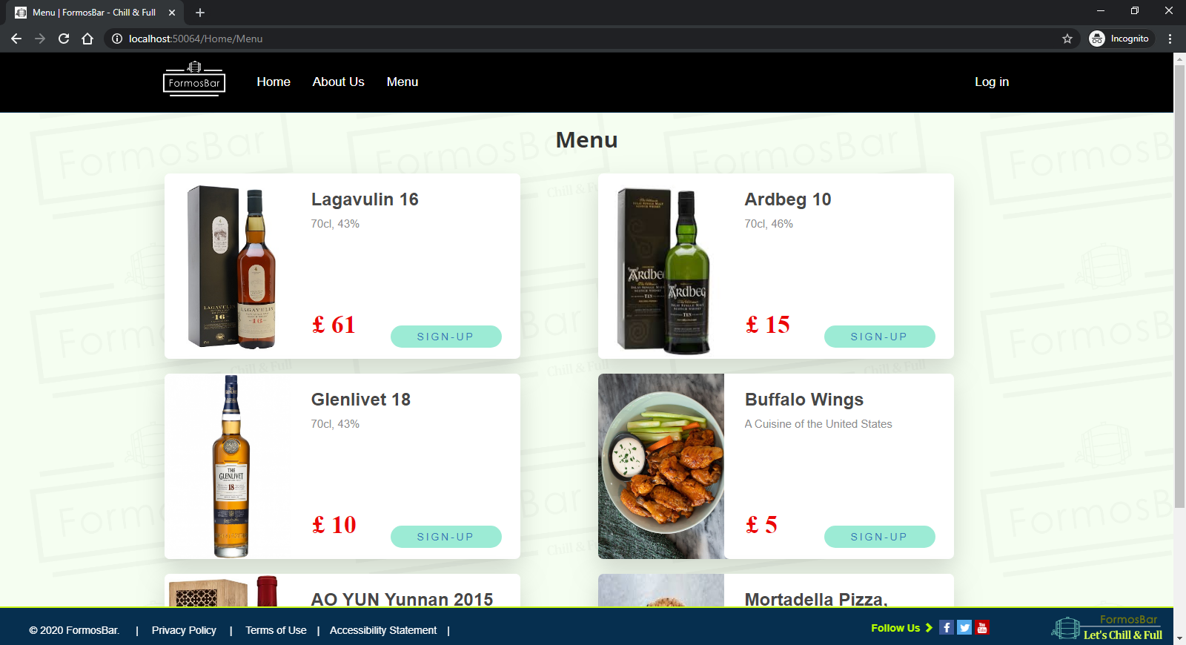
* FireFox  
    
  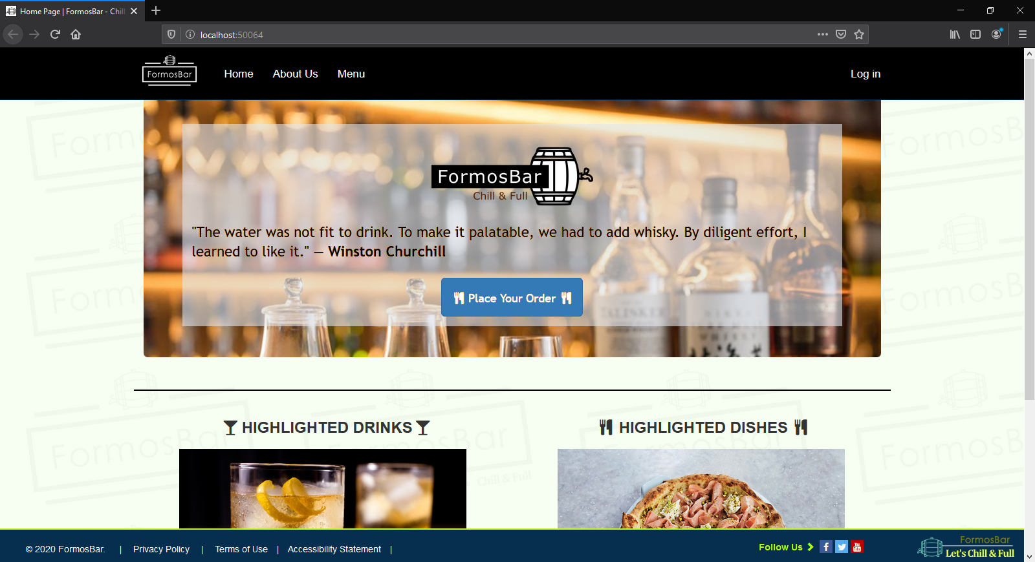  
    
  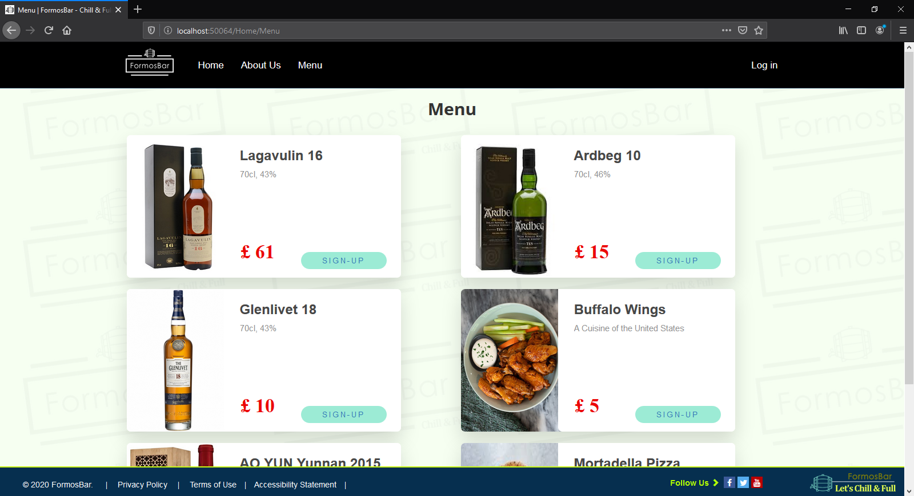

1. **Evidence of using the Web Accessibility Initiative (WAI) guidelines**
2. Using “Alternative Text and Title” (img src=”xx” alt=”xx” title=”xx”) For All Images  
     
   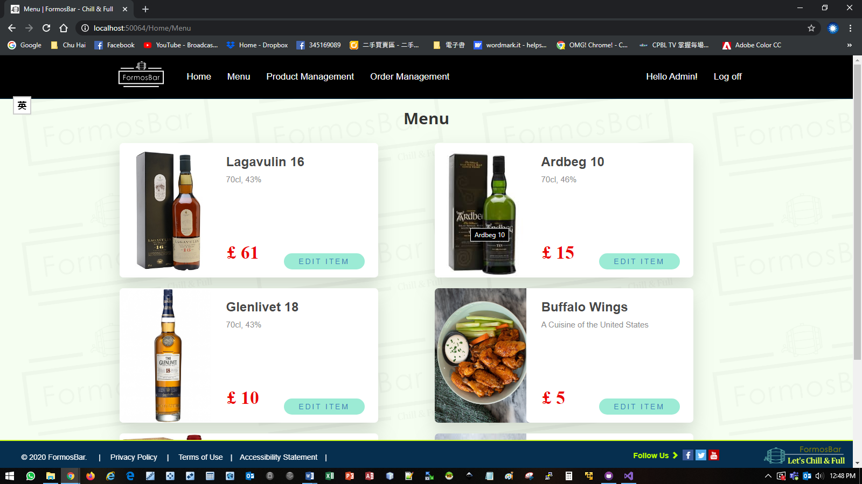   
     
   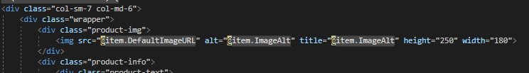  
     
   Commentary: The reason why using “alt” element is for disable person. When they use screen reader to access the webpage, screen reader will provide the exact wording description of that image to them.
3. Using “role = button” and “aria-pressed=”false” For All Buttons  
     
   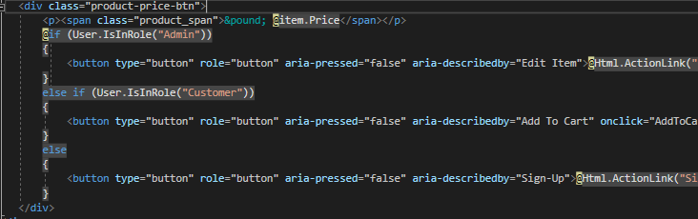  
     
   Commentary: The reason why using these two elements is to let the button appearing as a button control to a screen reader. And the “aria-pressed = “false” helps to indicate to disable person that the button is not currently pressed.
4. **Improvement**



1. **URL’s**

* API Middleware:

1. http://localhost:50064/api/Orders
2. http://localhost:50064/api/OrderDetails

* Hosted Web Page: http://localhost:50064/OrderService/index
* GitHub Repository: https://github.com/formosa77/FormosBar